I B. Tech. II Semester Supplementary Examinations – October, 2023
ALGEBRA
Time: 150 Min (CSE, IT(CSE(cs)) Max. Marks:80M

SECTION – A
Answer all Four questions 4×10M=40M

  - Let S be a non-empty set. What do you mean by a binary operation on S? Explain with an example.
  - Is 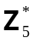= 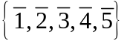a group under multiplication modulo 5, 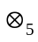? Verify.
Is it commutative? Justify your answer.

  - Let 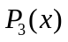be the set of all real polynomials of degree atmost 3. Consider the set .
Is linearly independent or not? Justify your answer.
  - Select a basis of the real vector space R⁴ from the set 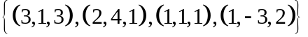if exists.

  - Distinguish order of a group and order of an element in a group.
  - What are all the elements in an abelian group whose order is 1?
  - Consider the statement
“In a finite group, order of any subgroup divides the order of the group.”
Is this statement valid? Provide a proof if its true or if false provide an example.

  - Show that the two sets 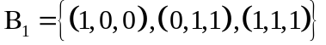 and 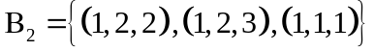 are bases of the vector space 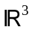.
  - Express the vector 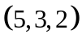as a linear combination of vectors of 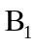 as well as vectors of 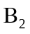. Write your observations.

SECTION - B
Answer all Two questions 2×20M=40M

  - Describe the symmetries of a square. How many elements are there?
  - Write the Cayley table for symmetries of a square and hence show that the set of symmetries of a square form a group under composition of maps.
  - Let 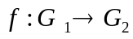be a group homomorphism and 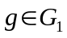. Is there any relation between the elements 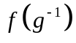 and 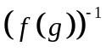? Justify your answer.
Also, what is the relation between the identity elements 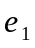 and 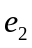.
- Consider the set, 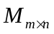, the set of all matrices with entries from the field of real numbers, R⁴.
  - Is this set a vector space over real numbers with respect to matrix addition and scalar multiplication? Verify.
  - Let  be the set of all non-singular matrices of . Can be regarded as a subspace of ? Mention conditions which make a subspace and prove the same.
  - What can we say about the dimension of the vector space 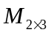? Justify your answer.
  - Can we define any linear transformation between the vector spaces 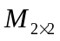 and R⁴? Justify your answer.

